1. What is a database? Explain briefly

* Database is a collection of data or information which are organized and structured and stored electronically in a computer system

1. Give example situations in which databases are used

* In student management systems
* In inventory management system
* In payroll management system
* In employee management systems

1. What is a database management system (DBMS)?

* Database management system is a software which use to read, write, update, delete data.
* It organizes and give access to manipulate data.

1. Give example DBMS available
   * MYSQL
   * MariaDb
   * Microsoft Server management studio
2. Compare and contrast different Data storage mechanisms.
3. a) What is known as the ANSI/SPARC model? Give another name for the ANSI/SPARC model.

* Commonly known as 3 schema architecture
* Conceptual framework that uses to develop DBMS
* There are 3 levels of this: External level, conceptual level, internal level.
* **External level** – user’s view of data, which means how they are presented through applications and interfaces.
* **Conceptual level** – Abstract view of entire database, which describes relationships between data and rules that govern them.
* **Internal level/Physical Level/schema** – physical storage of data on the computer system, including file structure and access methods.

b) Draw the Three Schema Architecture. Name the three schemas.

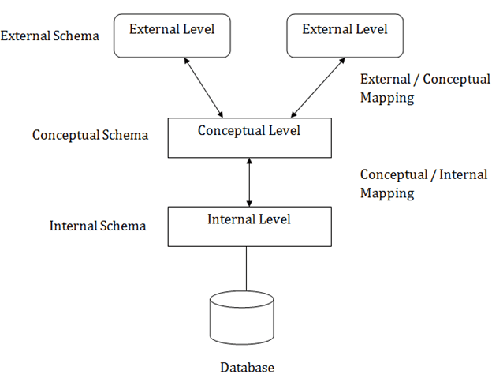

c) Briefly explain the 3 schemas.

* **Explained them above**.

d) What is the advantage of having the three-schema architecture?

* Can achieve data independence which means can do modifications in some layers without affecting others.

e) What do you mean by logical data independence and physical data independence?

* **Logical Data Independence –** can modify conceptual level without affecting external level.
* **Physical Data Independence –** Can modify internal level without affecting conceptual.

7. ‘Sri Lankan Airline is the national carrier’.

a) What is possible data required by an airline system?

* Arrival time of flights
* Departure time of flights
* Pilots Assign to flights
* Flight staff assign to flights

b) Is it necessary for them to use a DBMS?

* yes

8. Think of a DB of a bank.

1. What type of data would they store in their database?

* Employee details
* Customer account details
* Foreign bank details
* Current foreign currency value datils

1. In the three schema architecture where would you put details about above data?
   * Employee details – external
   * Customer account details - internal
   * Foreign bank details - internal
   * Current foreign currency value datils - internal
2. In the three schema architecture which schema describes details about the type of file organization used to store the above data?

* conceptual

1. What is the advantage of using a DBMS for a bank?
   * Easy to manage user details by reducing data redundancy
   * Easy to manage employee details and their salary
   * Able to get any currency value quickly with related to Sri Lankan rupee price

**End of the Tutorial**